**Exemplar: Adding a measure**

**Step 1: Download and connect to the Adventure Works Dataset.**

1. Download and save the Power BI project **AdventureWorks.pbix** from the Coursera platform. The model contains five tables of data: **Salesperson**, **Region**, **Date**, **Products** and **Sales**.
2. The Power BI project is already configured to remove duplicate values. As the following diagram outlines, you must ensure the model relationships are appropriately set with cardinality and cross-filter direction.

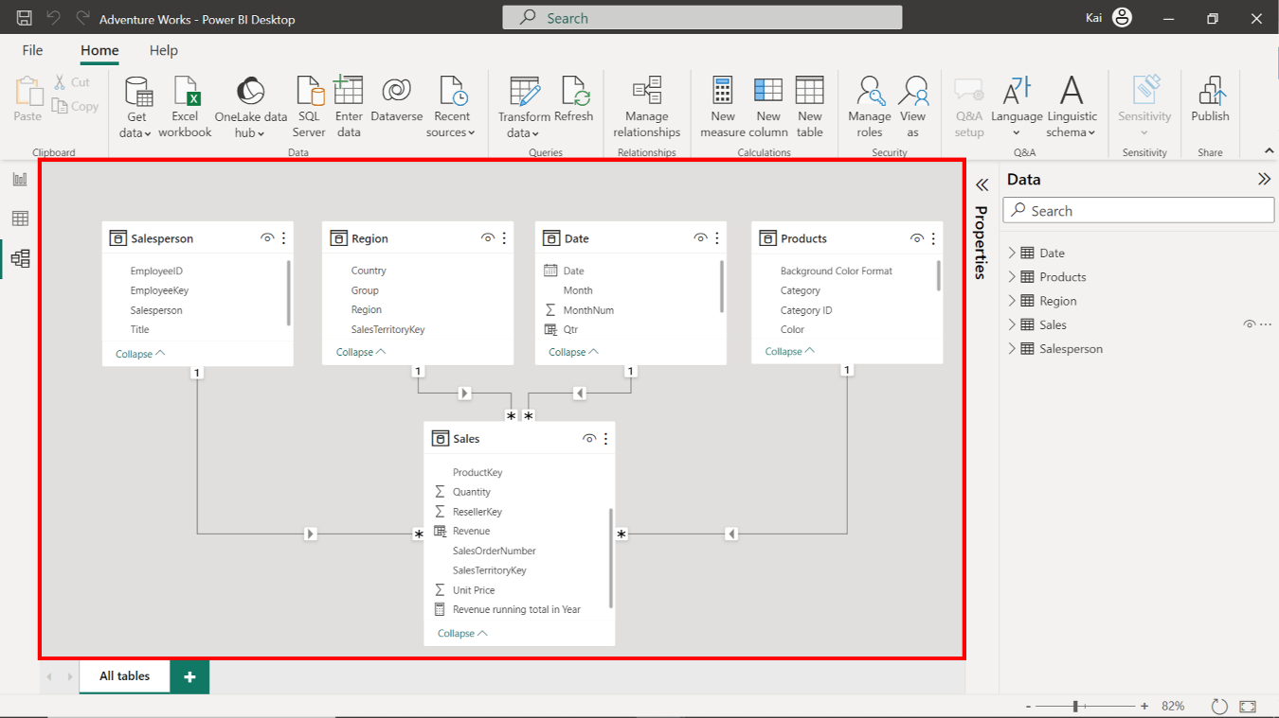

**Step 2: Create a Quick Measure.**

1. To create the **Running total in Year** quick measure, access the **Data view**, then **Calculations group**, and select **Quick measure** to open the **Quick measure window**.

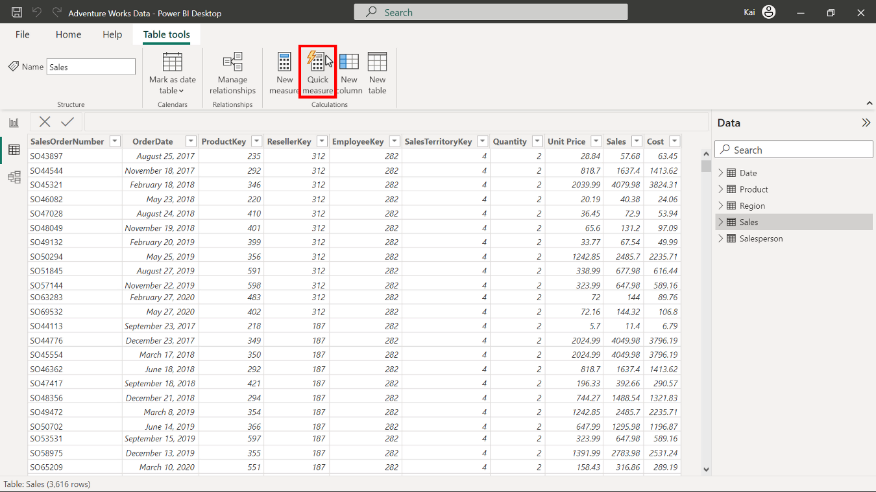

1. Under the **Calculations** dropdown menu, select **Running total** from the **Totals** calculation group.

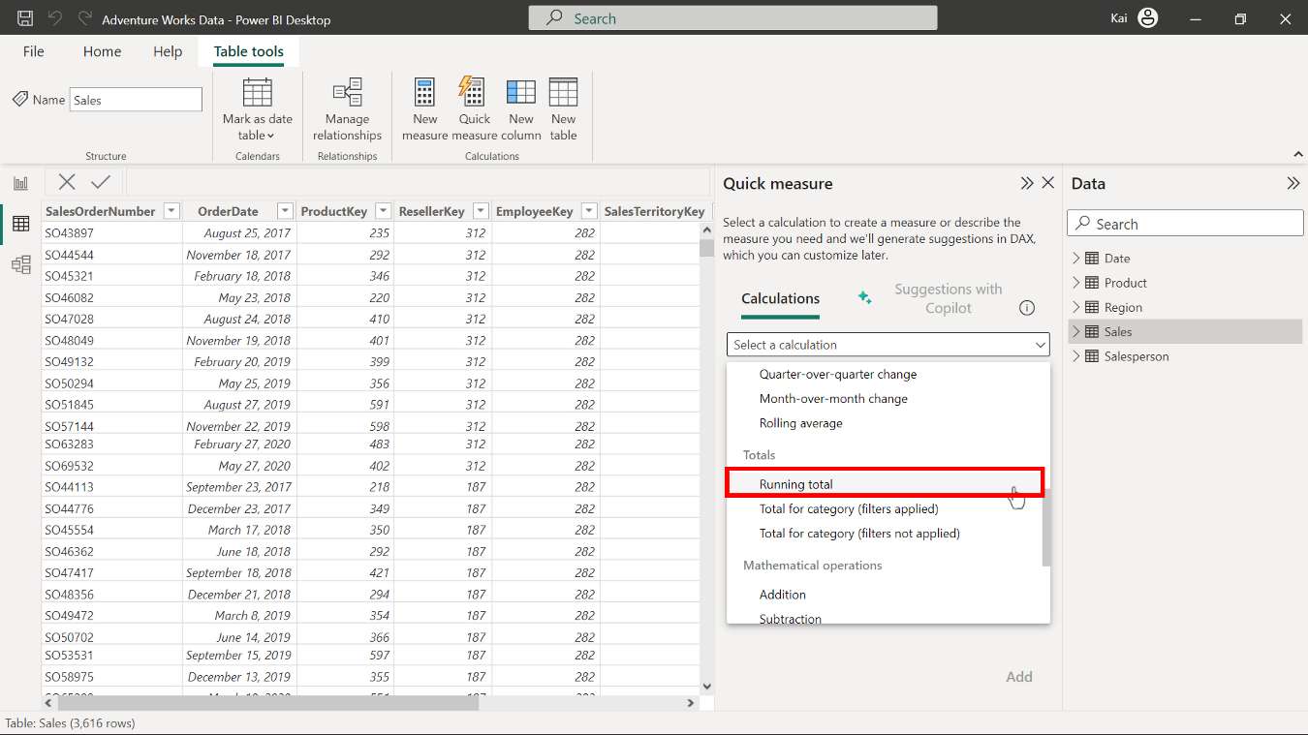

1. Drag the **Total Sales** column from the **Sales** table and drop it over the base value section. Drag the **Year** column from the **Date** table and drop over the **Field** section of the **Quick measure** dialog box. Retain the direction setting of **Ascending**.

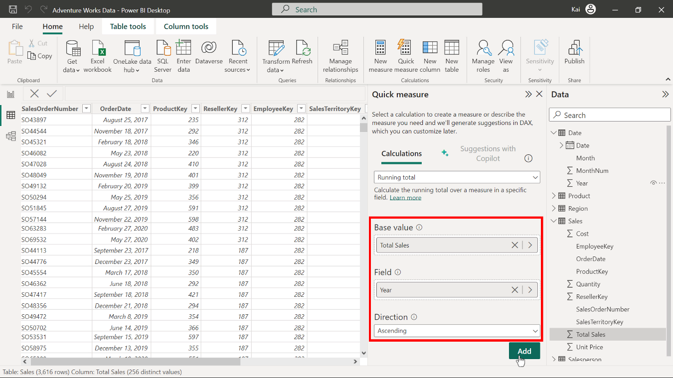

1. Select **Add** to complete the addition of your new quick measure. A new **Total Sales** measure appears in the **Data pane** under the **Sales** table.

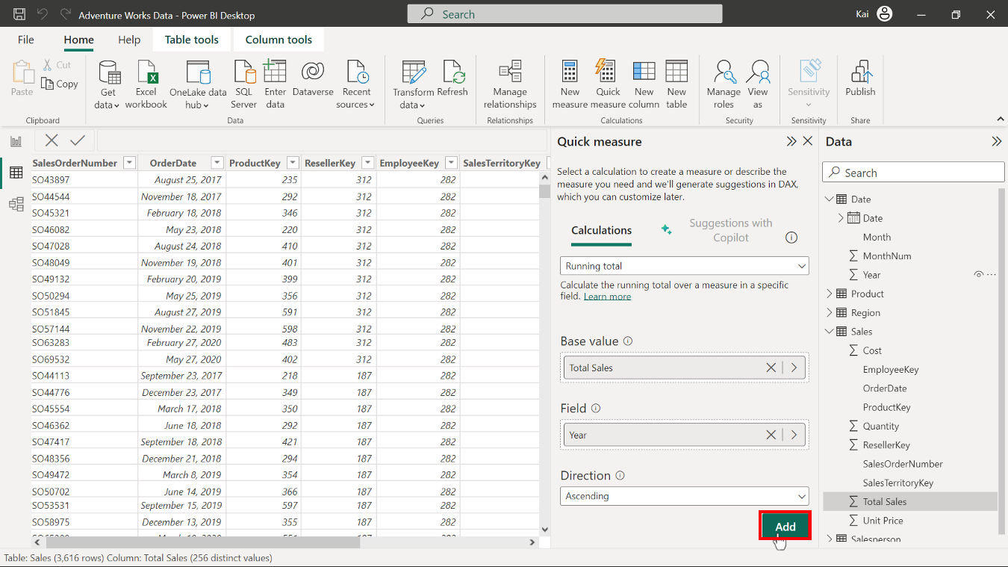

1. Power BI auto-generates the DAX code and names the measure as **Total Sales running total in Year**. Select the measure from the data pane, and in the formula bar, rename the measure as **Running total in Year**.

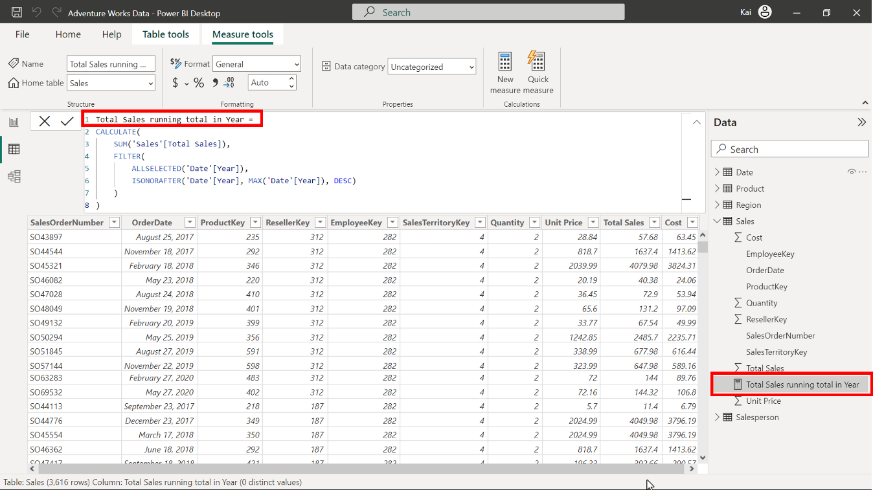

1. While selecting the measure, access the **Measure tools** tab and format the measure as **currency** with two decimal places.

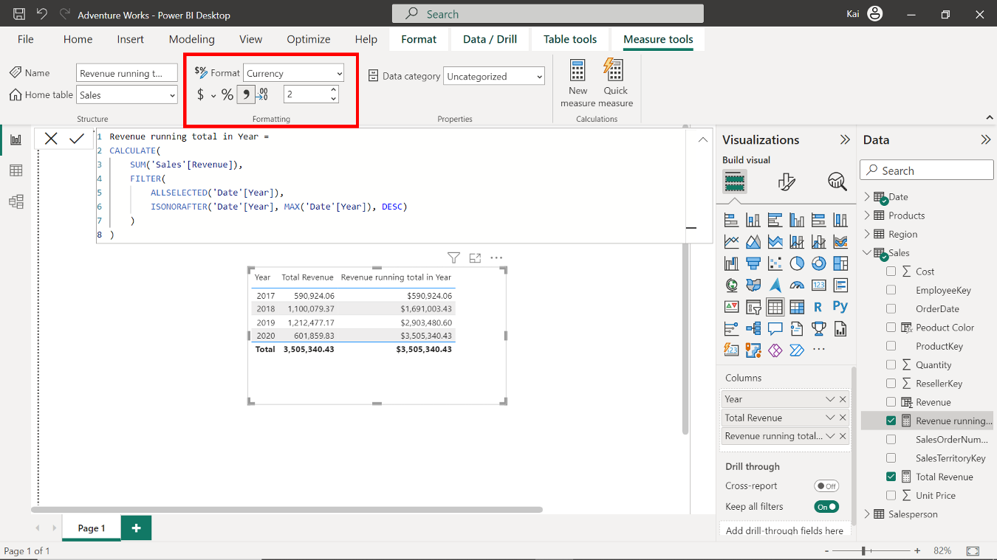

**Step 3: Create a measure using a DAX query.**

1. To create a new measure in the **Sales** table for **Total** revenue, select the **Sales** table from the **Data pane** on the right side of Power BI’s interface. Access the **calculations group** in the **data view** and select **New measure** to expand the formula bar. Copy and paste the following DAX code into the formula bar:

1

Total Revenue = SUMX ( Sales, Sales[Unit Price] * Sales[Quantity] )

* **Sales** is the table name to be referenced.
* **Unit price** and **Quantity** in square brackets are the columns that must be multiplied to calculate the total revenue.
* The **SUMX** function iterates over each table row to calculate the total revenue.

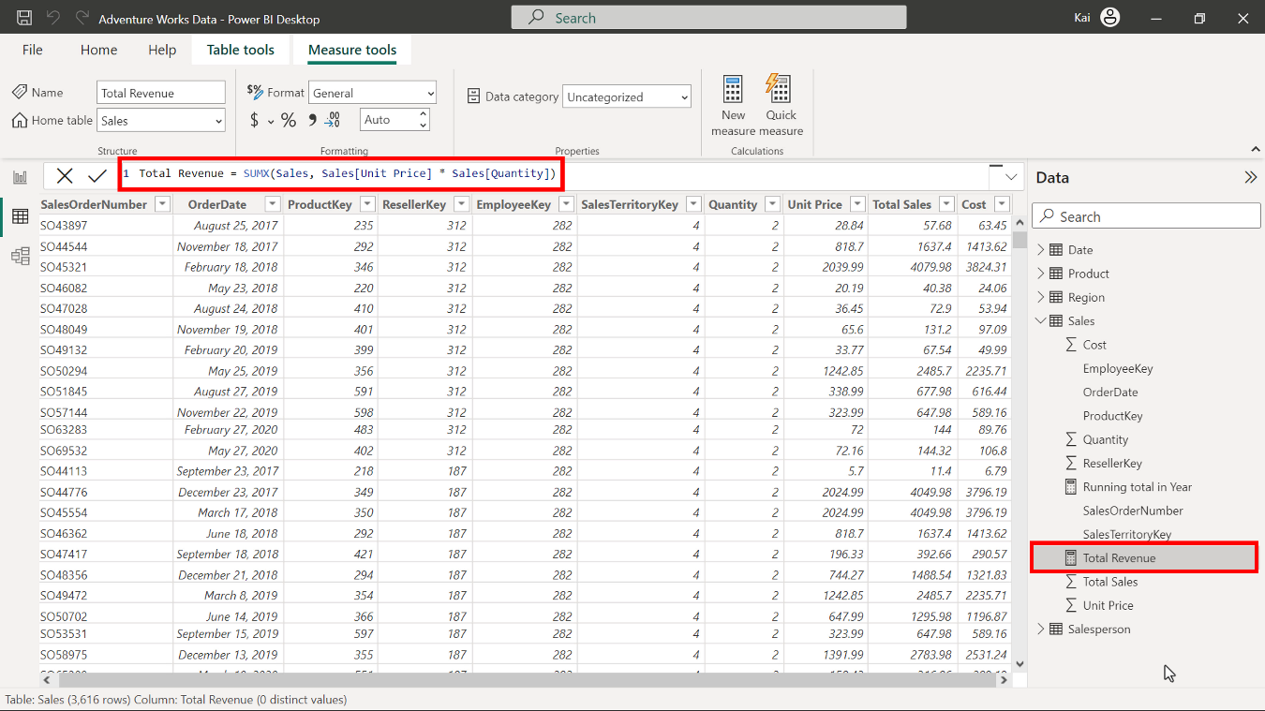

1. Select the newly created **Total Revenue**measure from the **Data pane** under the **Sales table**. Then access the **Measure tools** tab and format the measure as **currency** with two decimal places.

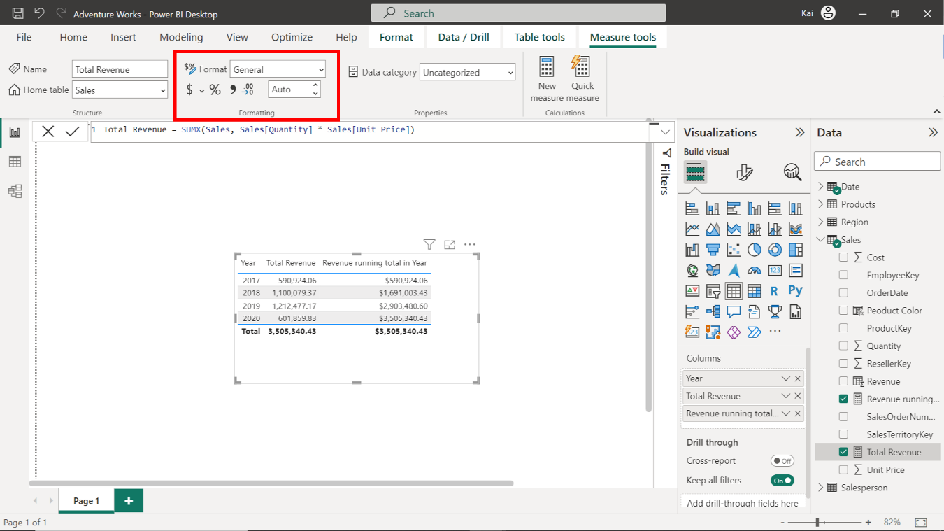

**Step 4: Save the Power BI project.**

To save the project, open the **File** menu, select **Save As,** and provide an appropriate name for the project along with a path to the folder on your computer.

**Conclusion**

With these steps, you have successfully created a quick measure in using Power BI desktop interface and one by writing DAX query. You can now analyze Adventure Works data based on the analytical and business requirements.

Remember that when using DAX formulas, you must always ensure they’re correctly formatted and that the column names match the actual column names in your data.